1. Write a procedure that take id, total_user, Yahoo, Hotmail, Gmail values as an

input and insert the data into the table summary.



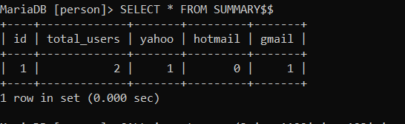

2. Write a procedure that take user_id, username, password, email values as an input

and insert the data into the table Users.

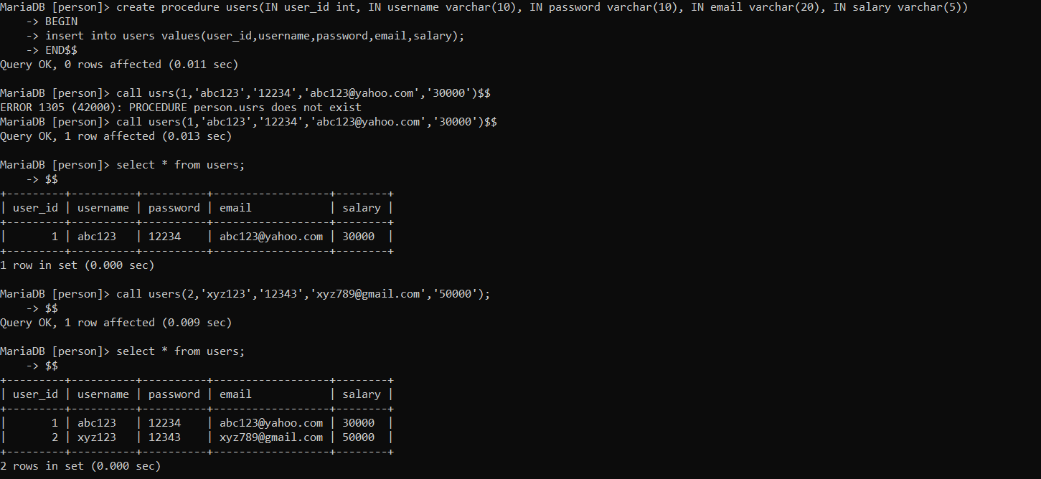

3. Write a procedure that output the total number of records/rows in the users table.

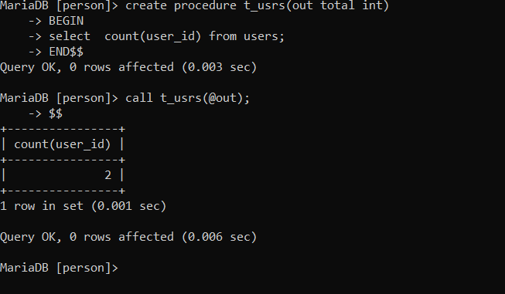

4. Write a procedure that output the average salary in the users table.

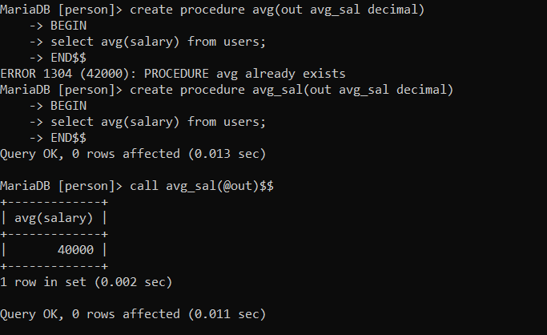

5. Create a procedure named minmax which displays the lowest and the highest salary of

the users. Run the procedure to display the lowest and the highest salary.

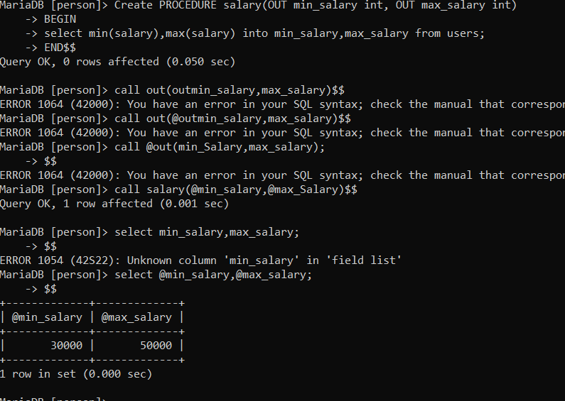

6. Create trigger(s) to update the records in the summary table. The summary table

will contain only one record and will be updated each time a new entry is made to

the users table, or a user is deleted from the users table. You need to create the

following two triggers.

I. Whenever a new entry is made to the user’s table then total_user attribute in

the summary table must be incremented by 1.

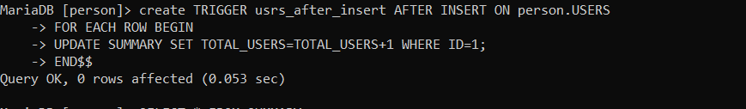

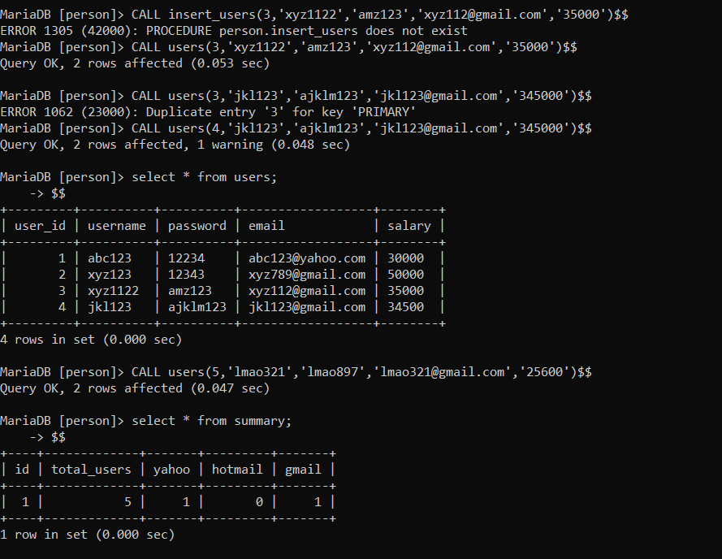

II. Whenever a record is deleted from the user’s table then total_user attribute

in the summary table must be decremented by 1.

